Course Section Date Controls EIB Steps
Last Updated 4.16.26 by Kristina Kelpe

Course Sections can have their own specific date controls. However, they don’t roll over with the Course Rollover functionality or Course Section EIBs. They have to be set up every academic period. Fortunately, it’s easy to set them up.
NOTE: This EIB will most likely update all course section date controls. Check to make sure none exist for the period you’re loading before starting (e.g. put in by Student Financials). Don’t accidentally wipe any!
- Generate a template from the Course Section Date Controls EIB. Go to:
  - INTSYS: Course Section Date Controls
  - Use the related actions to select Template Model and Generate Spreadsheet Template:
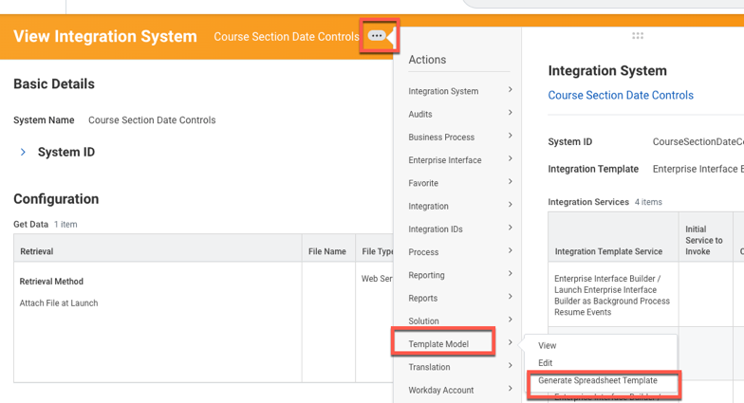
  - NOTE: You will sometimes need to update the Template Model. See other EIB documentation on how to do this. It should be updated about once a year at the minimum. It often gets updated after Workday releases. Using too outdated a version will cause your EIB not to work.
- Find a template from a prior course section date control that can be loaded.
  - If you need the Ref IDs for the date controls, you can generate this EIB with data. Ref IDs are listed below in this guide for what CLI typically needs.
- Run a report that has the reference IDs of the course definition sections you’ve built. For CLI sections, you can run the report: CLI Course Section Date Controls EIB Data. Select the academic period you want. If the dates will change, select one at a time for the EIB.
- Here’s what the EIB will ultimately look like:
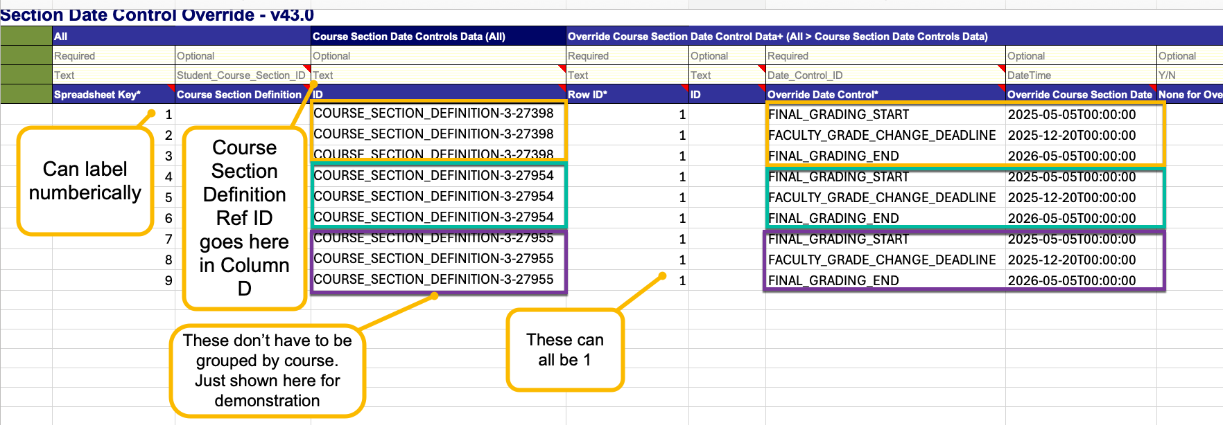
- Copy the reference IDs from this report into your EIB Template into Column D. Even though it says it is Optional Text, the blue section says ID. It is looking for the Ref ID:
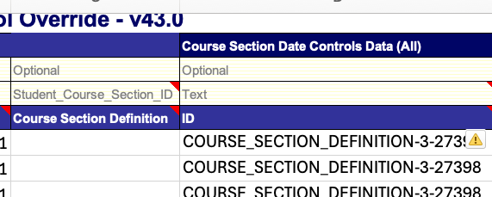
- Copy the Reference IDs in 2 more times. Add a date control reference ID to each time you copied the Ref IDs in.
  - FINAL_GRADING_START
  - FACULTY_GRADE_CHANGE_DEADLINE
  - FINAL_GRADING_END

